Ava Powers
December 1st, 2024
DSC 140
Dr. Julie Butler
Final Report Rough Draft
For my final project, I have decided to do my data analysis on a data set surrounding Formula One (1), an internationally popular racing sport composed of many different teams originating from different countries, and many different drivers and constructors from different countries. This data set specifically looks at the drivers, the constructors, the team (referred to as “car” in this data set”) in which the driver and constructor are associated, the total number of points that driver and constructor won throughout the season, and their overall rankings for the racing seasons beginning from 1950 and ending in 2021. I chose this data set because I grew up watching Formula One with my dad, and grew to love it as I got older. I also find it incredibly interesting from a personal and data science perspective, as it is a very unpredictable sport every season, as there are many factors that go into a driver, team, or constructor winning a race, let alone a season. The unpredictable nature of this sport was very prominent throughout my data analysis of this data set, as many of the results I got were unclear, not correlated, or did not follow a specific pattern, making it very difficult to get a “good” answer from tests such as machine learning and correlation scores. I chose this data set originally due to my interest in the sport but found myself becoming more interested and simultaneously frustrated at the lack of clear results, and sometimes lack of results in general. Nevertheless, I chose this data set because I believed it would be interesting to see if any tests could be done to make any predictions about the seasons, as well as make some discoveries about the nature of Formula One through exploratory analyses.
The first analysis I decided to conduct was focused on the constructor's championship, which is the championship to determine which team has engineered and maintained the best performing car in the season. With the constructors championship, I thought it would be interesting to see which team between the years of 1950 and 2021 has won the most constructors championship. To conduct this analysis, I first had to limit the data I was working with to only show me the teams which had a ranking or “Position” of “1”, or first place, in each season. The limiting of this data was done through the creation of a “mask”, and then a cross tabular calculation to group together the “1” positions from each team so that I was able to make a visualization of the data by means of a pie chart.
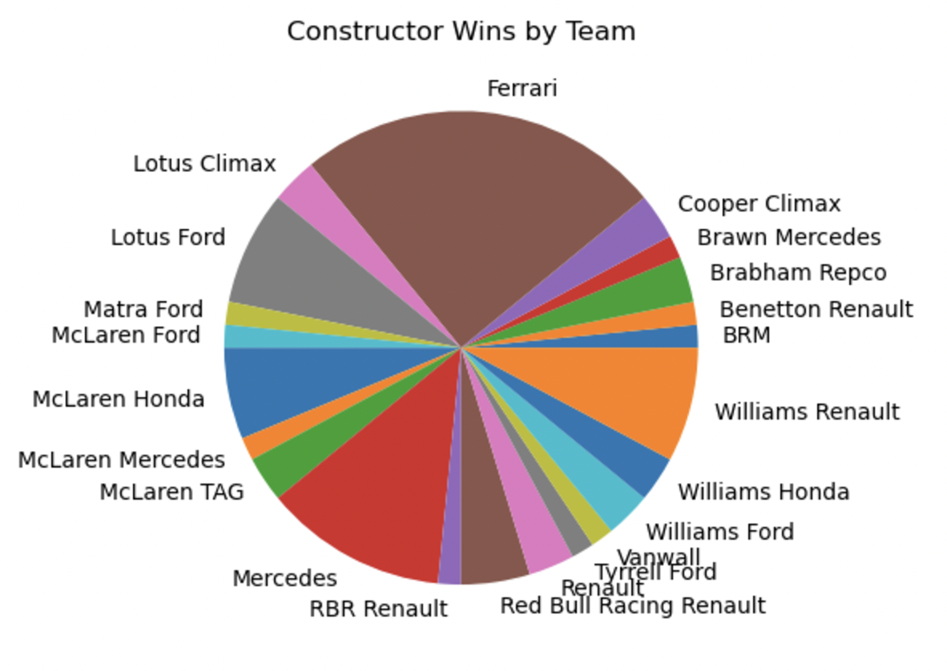
After conducted an analysis and creating a pie chart to visualize the analysis, it can be concluded that the team with the most first place or wins in the Constructors Championships from 1950 to 2021 was Ferrari, with Mercedes and Williams Renault holding the second and third most wins respectively.
The second analysis I wanted to conduct required the use of a machine learning algorithm, in this case, K-Nearest Neighbors. K-Nearest Neighbors is an algorithm that takes a given amount of the data set and uses it to group together similar data points and try to predict new data points from the groupings. I wanted to see if, using the winning constructor's championship teams from the past, if there was enough of a pattern in the winners to be able to accurately predict the results of the 2022 Constructors Championships. To conduct this analysis, I first had to split up my data set into training and test data so that the computer can learn and apply the data set it is given to make predictions. After the algorithm was trained and a prediction was made, a confusion matrix was created to determine how accurately the prediction was.
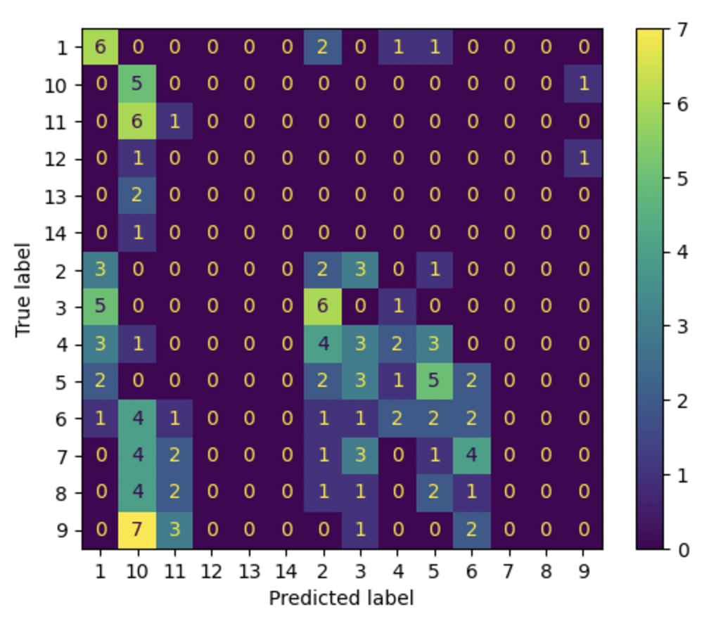
As you can see from the chart, the model failed to make a good prediction. This can be explained by the lack of data required to make such a difficult prediction, as well as the general difficulty to predict the outcomes of a sporting event involving so many different factors such as Formula 1.
For the next few analyses, I wanted to move away from the Constructors Championship and focus on the drivers, as, in Formula One, the results of the Constructors Championship is heavily dependent on the results of the drivers’ performances throughout the season. With the first analysis, I thought it would be interesting to see if there was any correlation between a driver’s nationality and the country of origin of the team they drive under, as it might makes sense that some drivers may want to drive under a team and car in which they share a culture and a flag. To conduct this analysis, I needed create a cross tabular to group together the columns of data containing the driver’s nationality and the teams or cars within Formula One. Then, I ran a Chi-Squared Test to determine if there was any correlation present between the two variables. After conducting an analysis, it was concluded that there is no correlation between the two variables, with a p-value of 0.0. This ultimately makes sense, as while many of the companies of cars share the same countries as many drivers, such as Antonio Giovinazzi, an Italian Driver (retired in 2023), racing for Ferrari, which is an Italian company, it is not more likely that an Italian driver will drive under an Italian-based car company, rather mere happenstance.
Additionally, I wanted to see if there would be any correlation between the position and the driver to determine if a certain driver was more likely to get a certain position. To conduct this analysis, I needed create a cross tabular to group together the columns of data containing the drivers themselves and the positions in which drivers can hold for each race, which range from 1 (first place) all the way to a disqualified ranking (DQ). Then, I ran a Chi-Squared Test to determine if there was any correlation present between the two variables. After conducting an analysis, it was concluded that there is barely any correlation between the driver and their ranking throughout the seasons, with a p-value of 1.55e-65, which is basically 0. This could be such for many reasons. For example, this data set is very large, as it takes into account 394 drivers from Formula 1 from 1950 to 2021, which could significantly shorten the number of times a position was earned by a driver due to having so many drivers. Additionally, there are 22 positions that have been taken into account with this specific analysis, which could also be responsible for lessening the number of times a driver earned a certain position.
The next part of my analysis involved finding any relationships present between numerical columns of data. The problem with this was, there was only one column of data in this data set that was numerical, meaning I would have to convert a categorical column into a numerical column. While I achieved this, it caused many difficulties in trying to conduct an analysis in which a clear, tolerable, or even acceptable answer could be found. This was also due to all of the other columns containing such a plethora of very different data points, such as the names of 394 drivers. Nevertheless, an analysis was conducted to find a correlation between drivers and the points they won and create a graph to visualize this potential correlation. However, its results proved themselves to be unsatisfactory. To conduct this analysis, I converted the category of “Drivers” into a list of codes to be associated with the name of each driver so that the column of data could be numerical. Then, after the column was converted, I conducted a Pearson’s and Spearman’s Correlation test to determine if there was any correlation between the drivers and their total seasons points. After conducting this analysis, it can be concluded that from the Pearson’s and Spearman’s correlation scores of 0.048 and –0.025 respectively, there is barely any correlation between the variables. Then, despite the small correlation, I visualized the data using a scatterplot and creating a line of best fit.
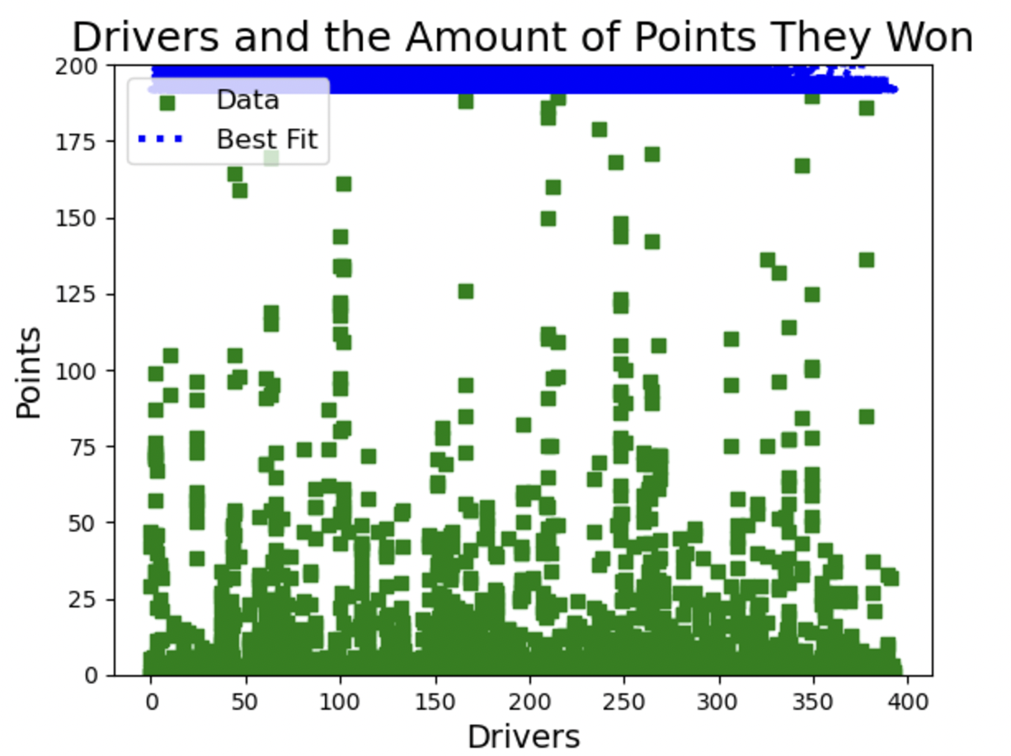
As you can see from the graph, the results are incredibly unclear. This is likely explained by the aforementioned difficulties of having to covert such a large categorical data column to a numerical column, which ultimately made reading the data more confusing, as there are no longer names attached to the drivers, only numbers.
Finally, I wanted to conduct an analysis focusing on any correlations between the nationality of the drivers and the number of points the earned resulting in their ending position of the season using new visualization techniques, specifically using the seaborn library. The seaborn library offers new and unique types of data visualization that I thought would be interesting to apply to this data set, as it involves so many columns with many different data points. Firstly, I wanted to see if there was certain nationality of driver which earned the most points and held the highest position in Formula One for that respective season. To do this, I created a relationship plot, or a “relplot” as its is known within the seaborn library. This specific plot not only maps the x and y data points you give it, but the sub data points within x and y.
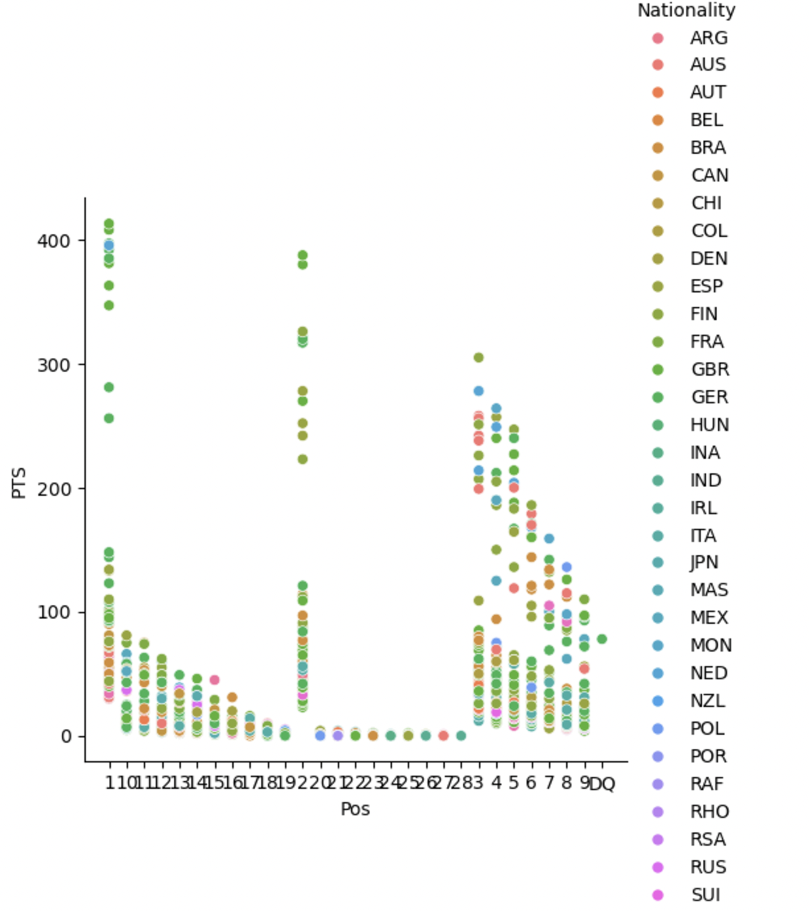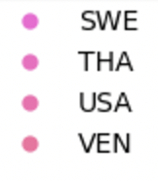
As you can see from the plot, the Drivers belonging to Great Britain “GBR” hold the most overall points and 1st place positions from 1950 to 2021 in Formula One.
Finally, I wanted to use another seaborn visualization technique to determine which nationality of drivers from 1950 to 2021 has been the most prominent. To do this, I used a plot similar to the relationship plot known as a distribution plot, or “displot”. This plot also takes into account the x and y data points, as well as the sub-points within x and y and distributions them according to other similar sub-points.
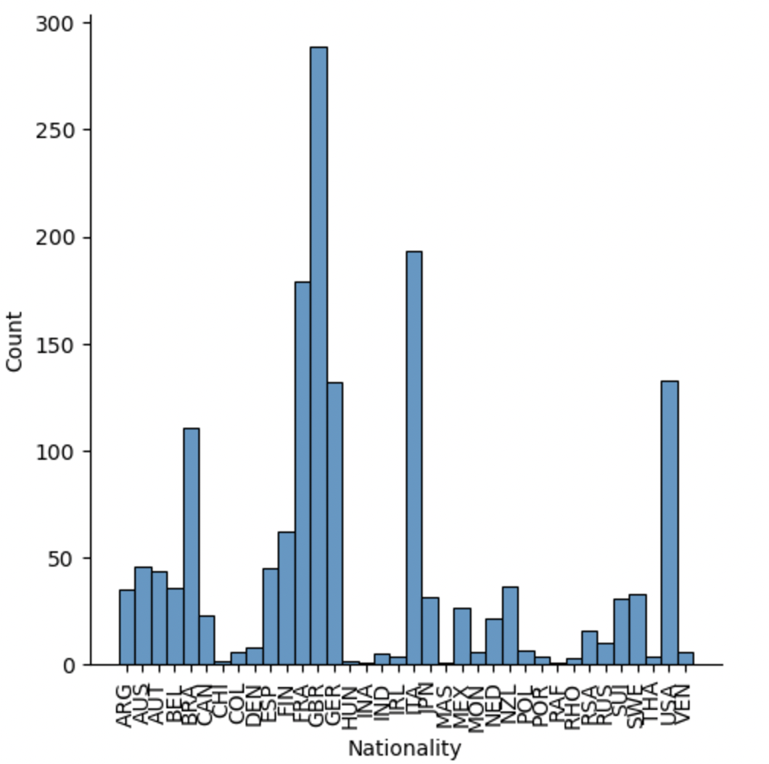
As you can see from the plot, once again, Great Britain has had the most drivers represented in Formula One from 1950 to 2021.
Overall, this data analysis was difficult to conduct, as there were many changes that need to be made to the data itself in order to run the necessary tests, and even after the tests were conducted, the result was either inconclusive or unsatisfying. This goes to show just how difficult it is to predict the outcomes from sports with as many external factors contributing to the results, which would be incredibly difficult to contain into a data set or begin to visualize. Despite this, some results were still able to be uncovered, and did contribute to my knowledge of the sport.

References
https://www.kaggle.com/datasets/mustafatomak/formula-1-dataset-1950-2021?resource=download&select=F1_Driver_Standings.csv
Waskom, M. L., (2021). seaborn: statistical data visualization. Journal of Open Source Software, 6(60), 3021, https://doi.org/10.21105/joss.03021.

